30 people were given snacks to eat while they were at a “Healthy Choices” luncheon. They were then asked to rate their snacks on a 1 (not healthy) to 10 (very healthy) point scale. The ratings are below.

cheese candy fruit

6 3 4

7 2 5

8 3 6

6 4 5

5 2 4

6 1 7

7 2 6

6 3 5

5 4 3

7 3 6

Is there a significant difference (using p<.05) in the ratings for snacks?

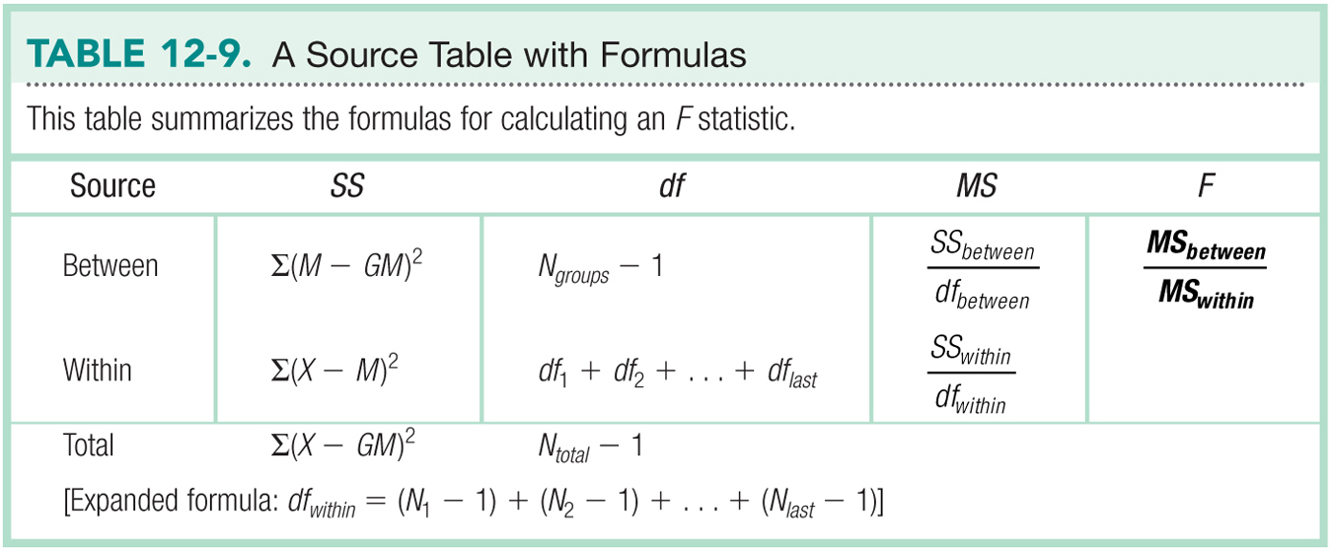

*n

|  |  |  |  |  |
| --- | --- | --- | --- | --- |
| Variance Type | SS | *df* | *MS* | *F* |
| Between groups  (IV) |  |  |  |  |
| Within Groups  (error) |  |  |  |  |
| Total |  |  |  |  |

|  |  |
| --- | --- |
| Step 1 |  |
| Step 2 |  |
| Step 3 |  |
| Step 4 |  |
| Step 5 |  |
| Effect Size |  |

Bonferroni Post Hoc

|  |  |  |  |  |
| --- | --- | --- | --- | --- |
| Group 1 | Group 2 | P-value | Comparison | Reject? |
|  |  |  |  |  |
|  |  |  |  |  |
|  |  |  |  |  |

NOTE:

* Manual Bonferroni correction:
  + When you run post hoc t-tests with no correction, you would check *p-*found against *p-*critical *= alpha* / *number of comparisons.* Remember that alpha is usually .05 or .01 defined in the problem.
  + You want *p*-found to be less than *p*-critical.
  + For example, your alpha = .05, your number of comparisons = 5. Therefore *p*-critical = .01.
    - If your uncorrected t-test *p*-found was .02, you would **fail to reject**.
    - If your uncorrected t-test *p*-found was .005, you would **reject the null.**
* Pairwise.t.test in *R*:
  + When you use pairwise.t.test with a built in p.adjust.method for Bonferroni, it **corrects the p value for you.**
  + That means you can compare *p*-found adjusted to *alpha* defined in the problem.
  + Most people like this method because it means they are always comparing to *alpha* rather than having to remember to compare to a new cut off score.